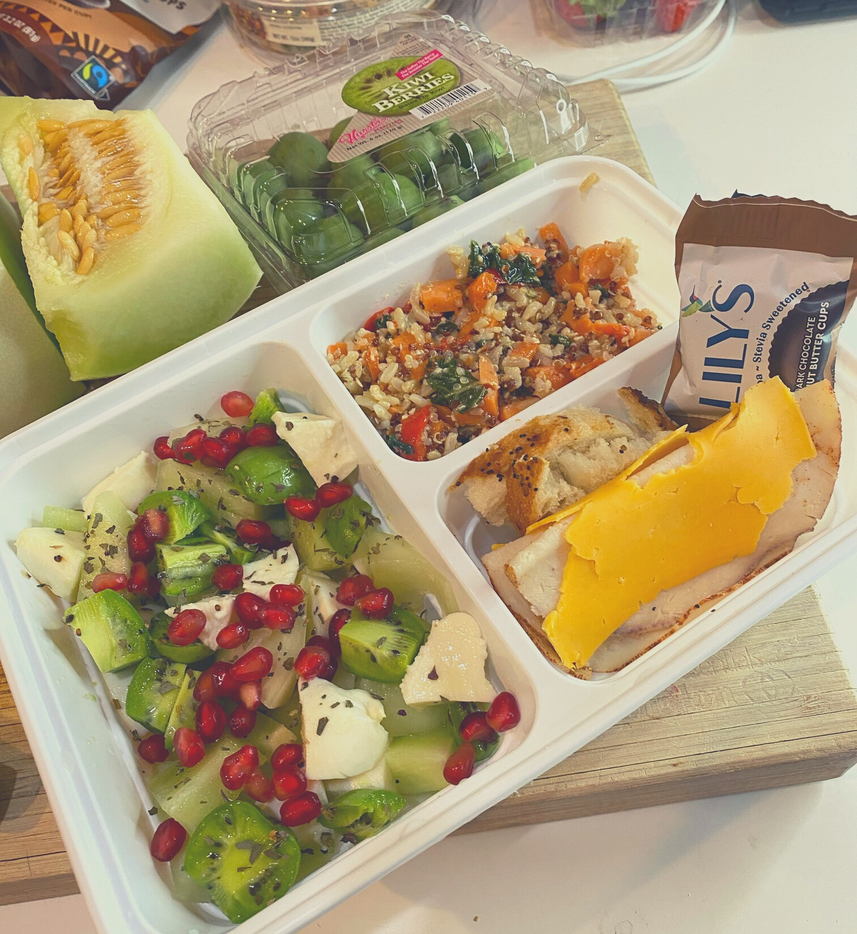
MEAL PREP GUIDE!!
B Y D I E T I T I A N D A D

F O L L O W M Y " P S P M E T H O D F O R
S U C C E S S !
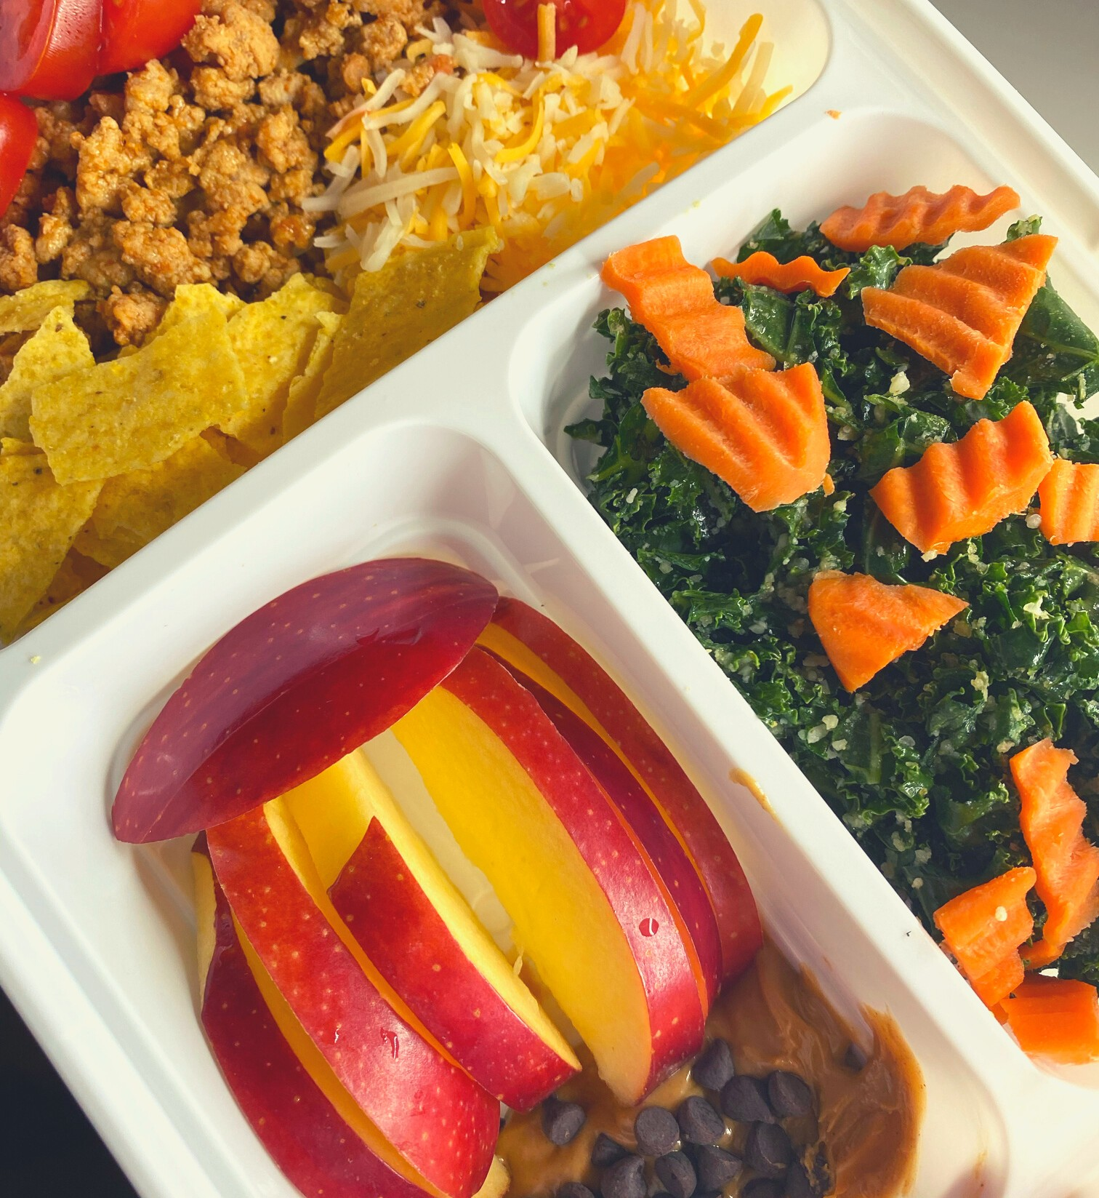
P : P L A N ( 1 H O U R ) S : S H O P ( 1 H O U R ) P : P R E P ( 1 H O U R )
R E M E M B E R ! W I T H O U T A P L A N , M O S T O F U S E N D U P E A T I N G
F O O D S W E D I D N ' T " P L A N " T O E A T A N D
E N D U P R E G R E T T I N G
S T E P 1 :
M A K E L I S T S O F Y O U R F A V O R I T E P R O T E I N S ,
F R U I T S / V E G G I E S , C A R B S , A N D C O N D I M E N T S
S T E P 2 :
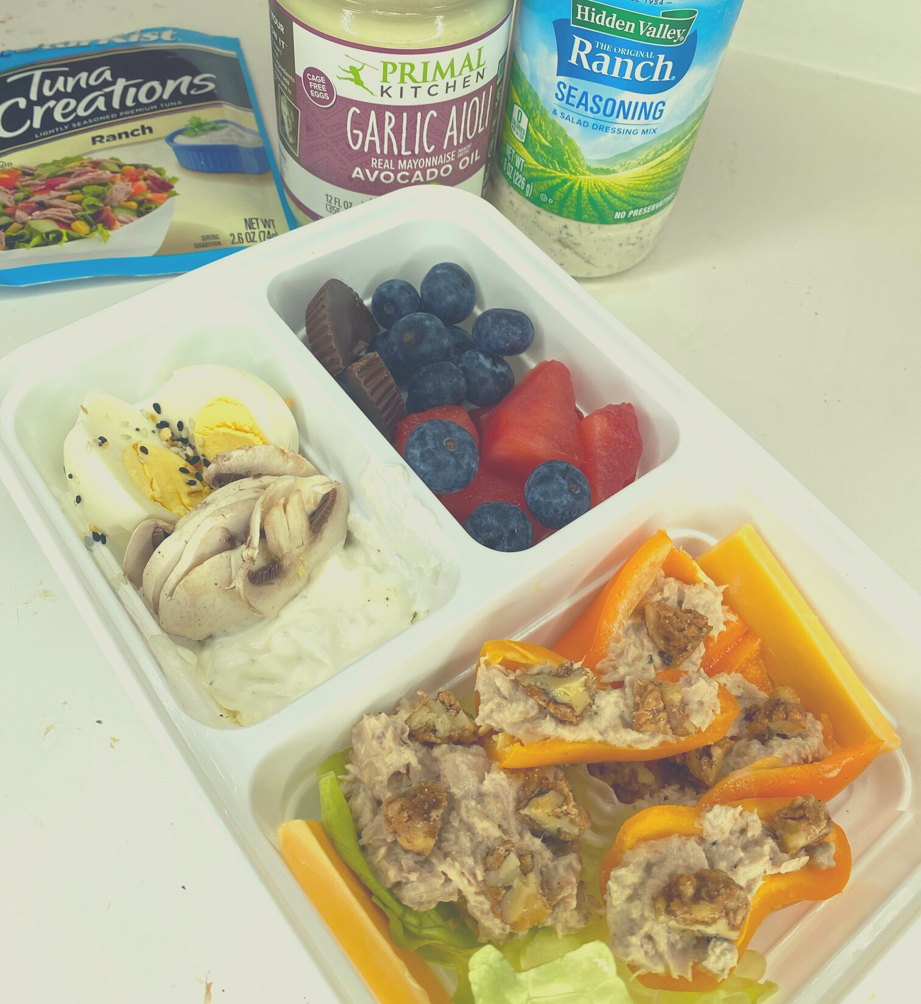
F I N D 1 M E A L R E C I P E A N D 1 S N A C K R E C I P E F O R E A C H P R O T E I N Y O U L I K E
( P R E F E R E B L Y O N P I N T E R E S T ) . D O T H E S A M E F O R E A C H
F R U I T / V E G G I E A N D C A R B T H A T Y O U L I K E A S W E L L . Y O U
S H O U L D H A V E A T L E A S T 5 D I N N E R S / L U N C H E S A N D 5 S N A C K I D E A S .
S T E P 3 :
C R E A T E A S H O P P I N G L I S T . S E P A R A T E I N G R E D I E N T S B Y
P R O T E I N , F R U I T , V E G G I E S , A N D S T A R C H E S T O M A K E T H E
S H O P P I N G T R I P Q U I C K E R .

BENTO BOX MEAL PLAN
DIETITIAN DAD
MONDAY Sweet peppers, cucumbers, 2 hard boiled eggs with Everything
seasoning. Greek yogurt with
strawberries and Cilantro Dill dip

TUESDAY Carrots and hummus. Deli turkey with string cheese, grapes, and goldfish
WEDNESDAY Smoked salmon, dill dip, hard
boiled egg, sea salt crackers, cucumbers and raspberries
THURSDAY Shrimp salad with mango, avocado,
and tomato on a bed of greens.
Edamame and dark chocolate with cashews

FRIDAY Kale salad, apples with peanut butter and chocolate chips, taco salad with
turkey meat, corn tortillas, cheese, and tomatoes

WWW.DIETITIANDADNUTRITION.COM FOLLOW ME ON INSTA FOR MORE RECIPES @DIETITIAN_DAD

